1. Getting Started with Backend

Accessing the Backend:

To access the backend of the sea-cargo logistics application, you need to download the backend files from our GitHub repository. You can find the repository at [GitHub repository URL]. Once downloaded, extract the files to your local machine.

Running the Backend Locally:

To run the backend locally, ensure that you have Node.js and npm installed on your machine. Open a terminal or command prompt, navigate to the extracted backend folder directory, and run the following commands:

-> npm install

-> npm start

This will install the necessary dependencies and start the backend server locally. The backend server will typically run on port 8080 by default.

2. Getting Started with Frontend

Accessing the Frontend:

To access the frontend of the sea-cargo logistics application, you need to download the frontend files from our GitHub repository. You can find the repository at [GitHub repository URL]. Once downloaded, extract the files to your local machine.

Running the Frontend Locally:

To run the frontend locally, ensure that you have Node.js and npm installed on your machine. Open a terminal or command prompt, navigate to the extracted frontend folder directory, and run the following commands:

-> npm install

This will install the necessary dependencies.

3. Dashboard Overview

Customer Dashboard:

The customer dashboard provides an intuitive interface for customers to manage their sea-cargo logistics needs. It includes dedicated sections for order management, shipment tracking, and account settings.

Key Features for Customers:

* Order Management: Easily create new orders, view order history, and track the status of existing orders.
* Account Settings: Manage account information and update contact details.

**Customer Login/Register:**

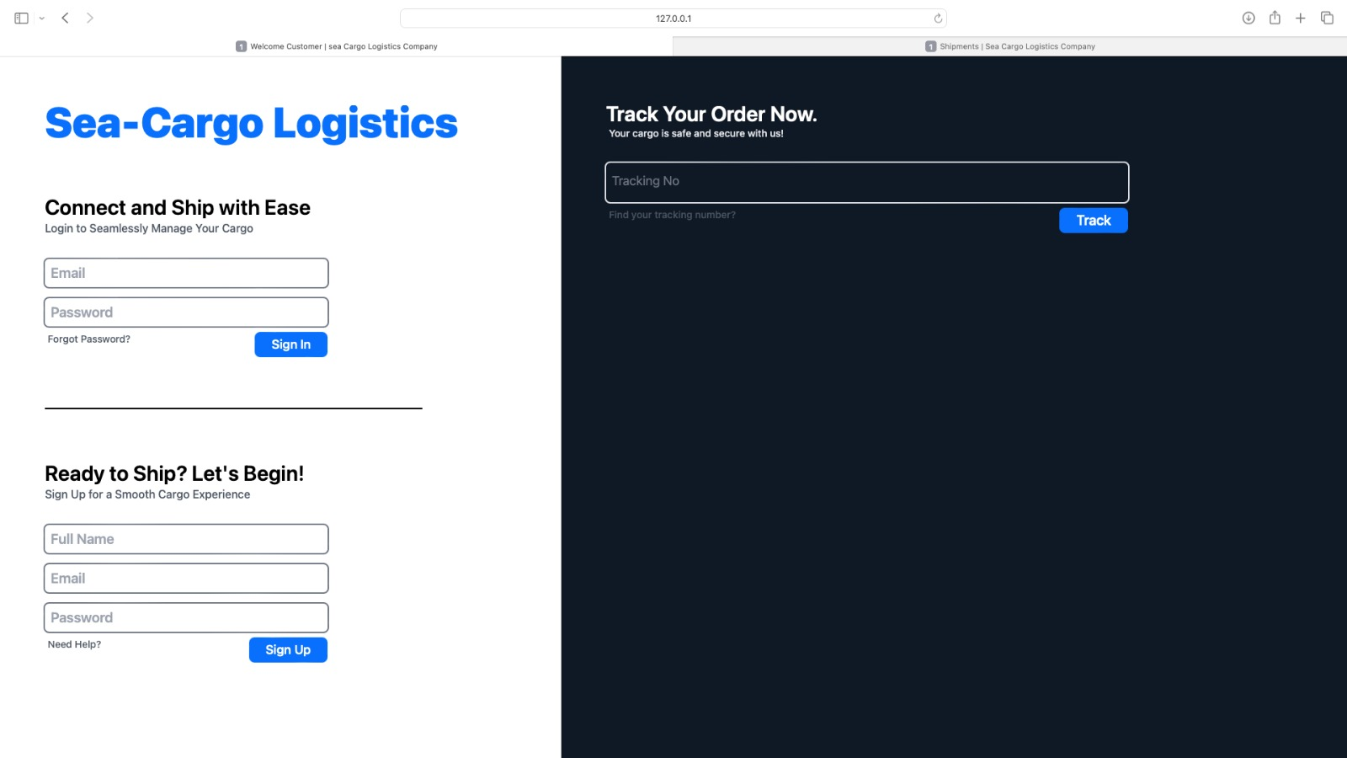

**Customer Dashboard:**

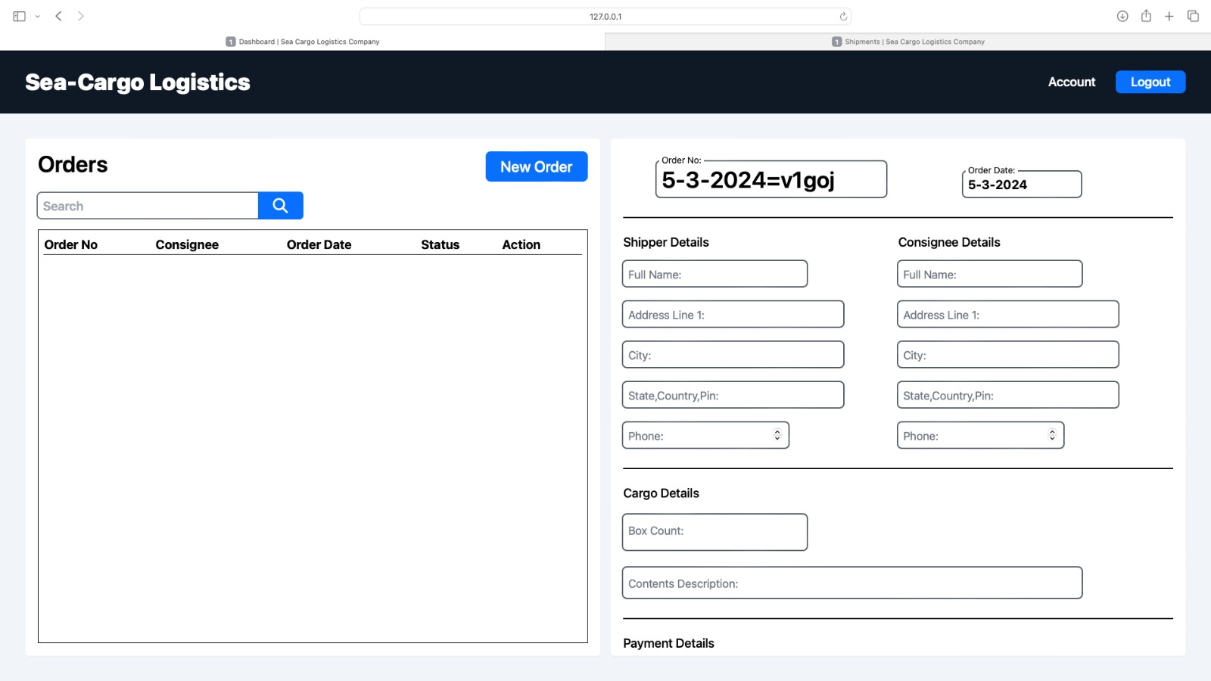

User Dashboard (Agents, Managers, etc.):

The user dashboard provides comprehensive tools for agents, managers, and other authorized users to manage sea-cargo logistics operations efficiently. It includes modules for order management, warehouse inventory, shipment processing, and user settings.

Key Features for Users:

* Order Management: Create, edit, and manage orders, assign agents, and track order status from pickup to delivery.
* Warehouse Management: Monitor warehouse inventory levels, manage stock, and fulfill orders efficiently.
* Shipment Processing: Create new shipments, consolidate orders, assign carriers.

**User Login:**

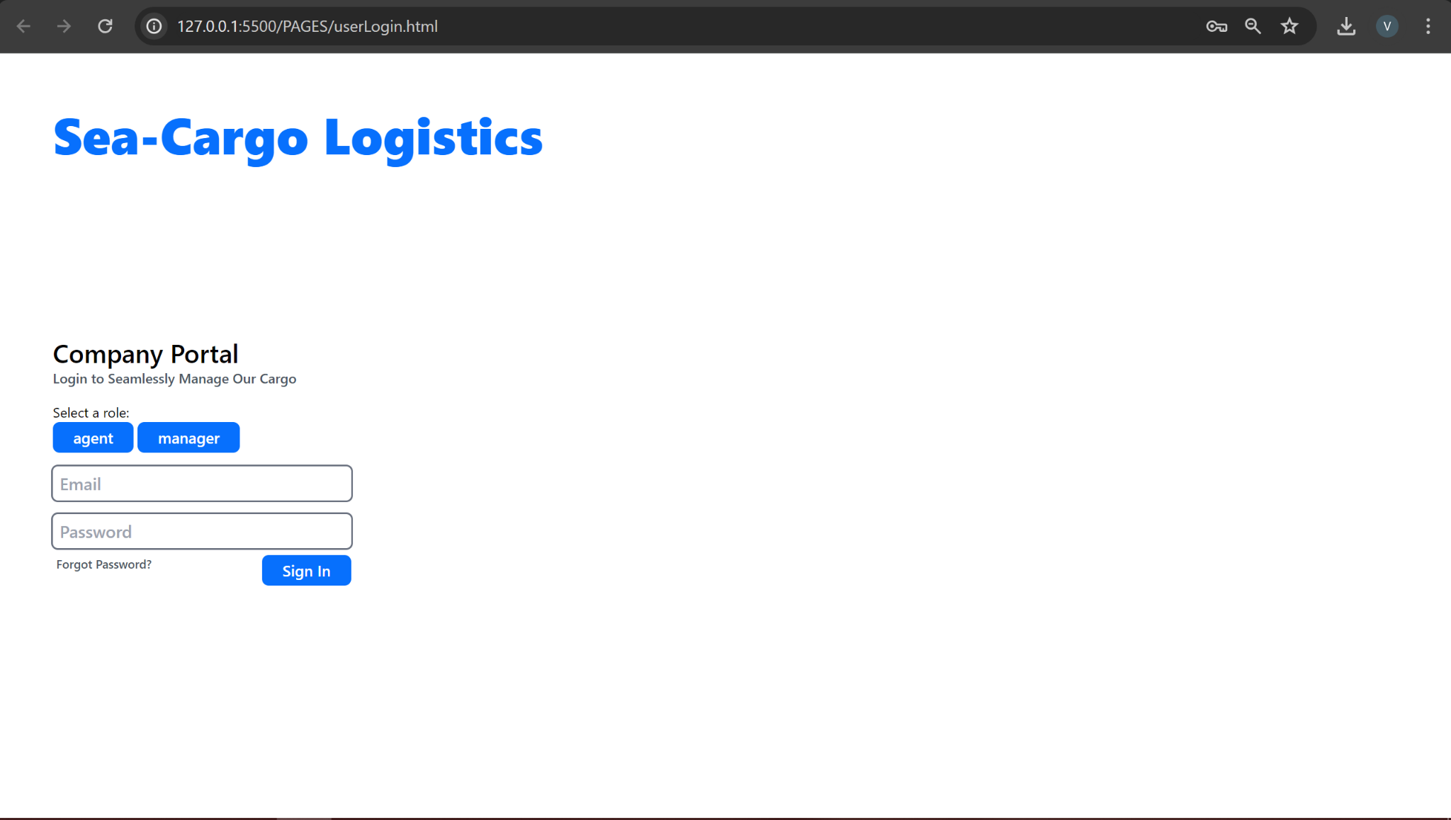

**User Dashboard:**

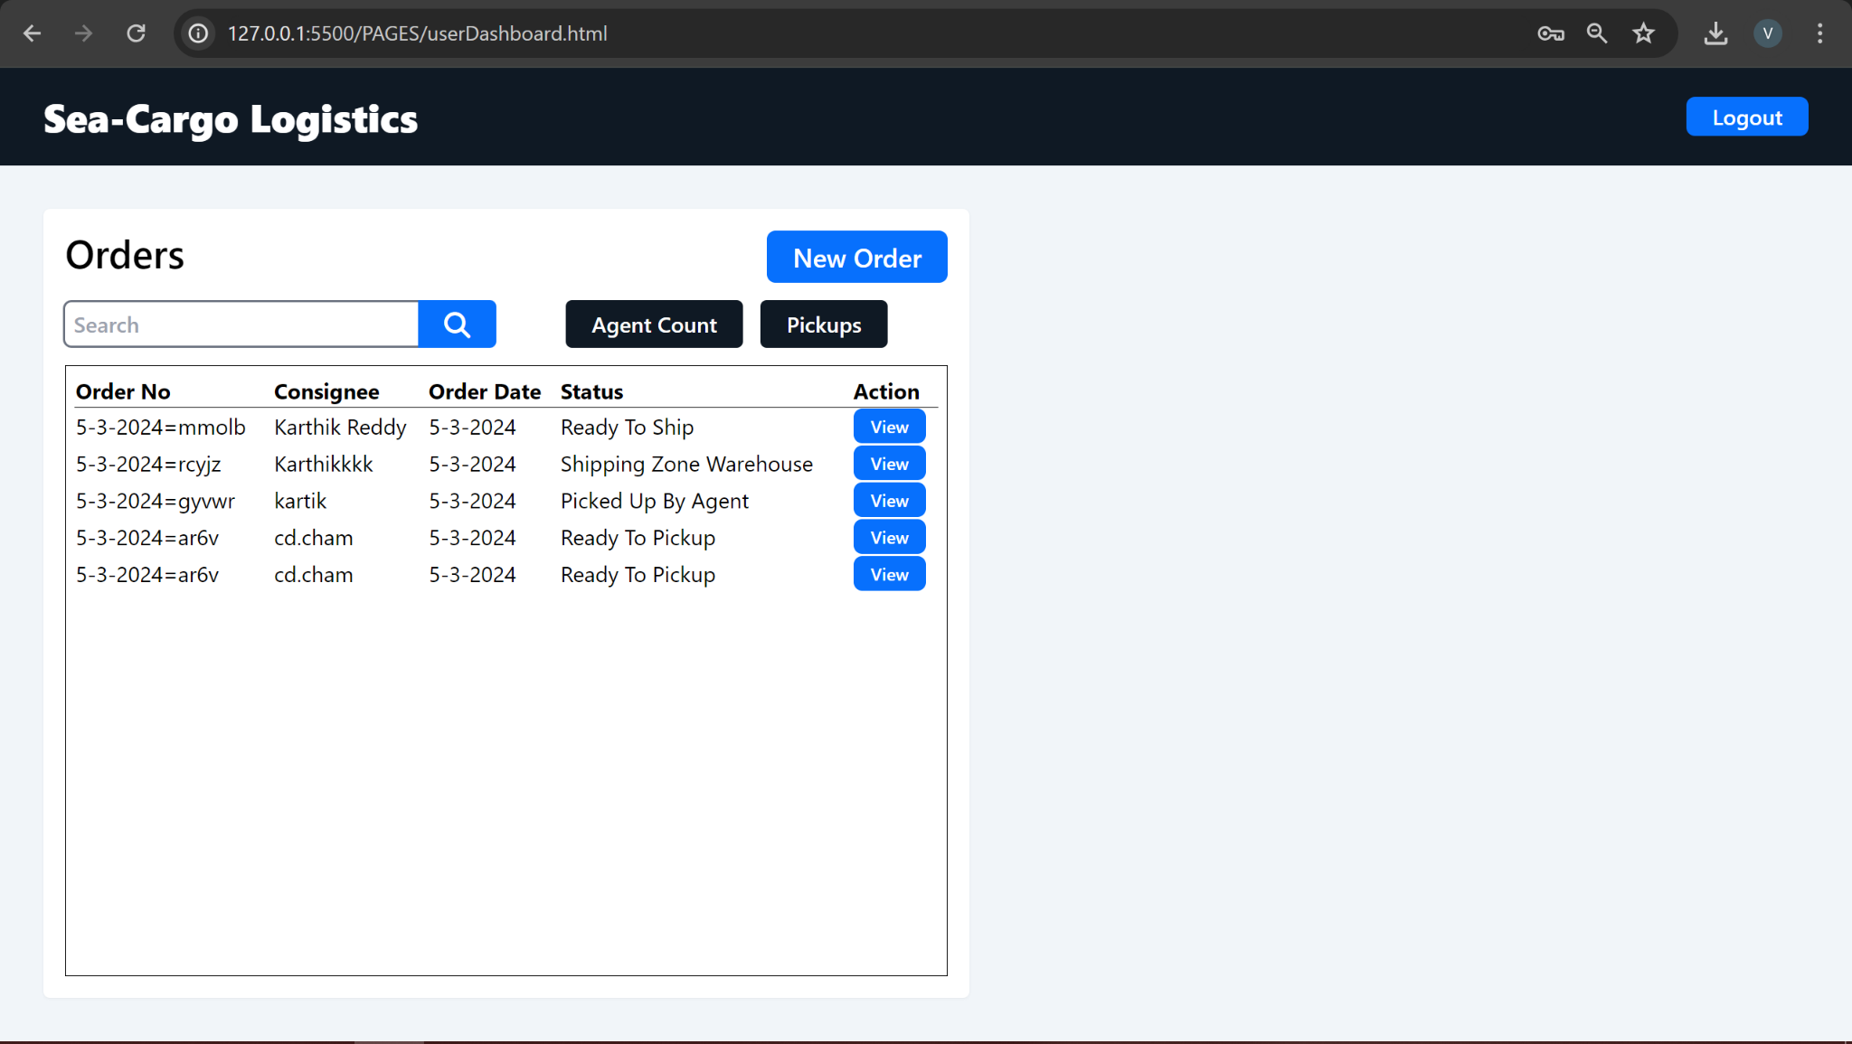

4. Managing Orders

Backend Order Management:

The backend order management module allows administrators and authorized users to create, view, and manage orders efficiently. It includes functionalities for adding new orders, editing existing orders, and tracking order status.

Key Features for Backend Order Management:

* Create New Orders: Add new orders to the system by entering shipment details, shipper and receiver information, and cargo specifications.
* View and Edit Orders: Access a list of existing orders, search and filter orders based on various criteria, and update order details as needed.
* Track Order Status: Monitor the status of orders in real-time, including processing, pickup, transit, and delivery stages.

**Order Scheme:**

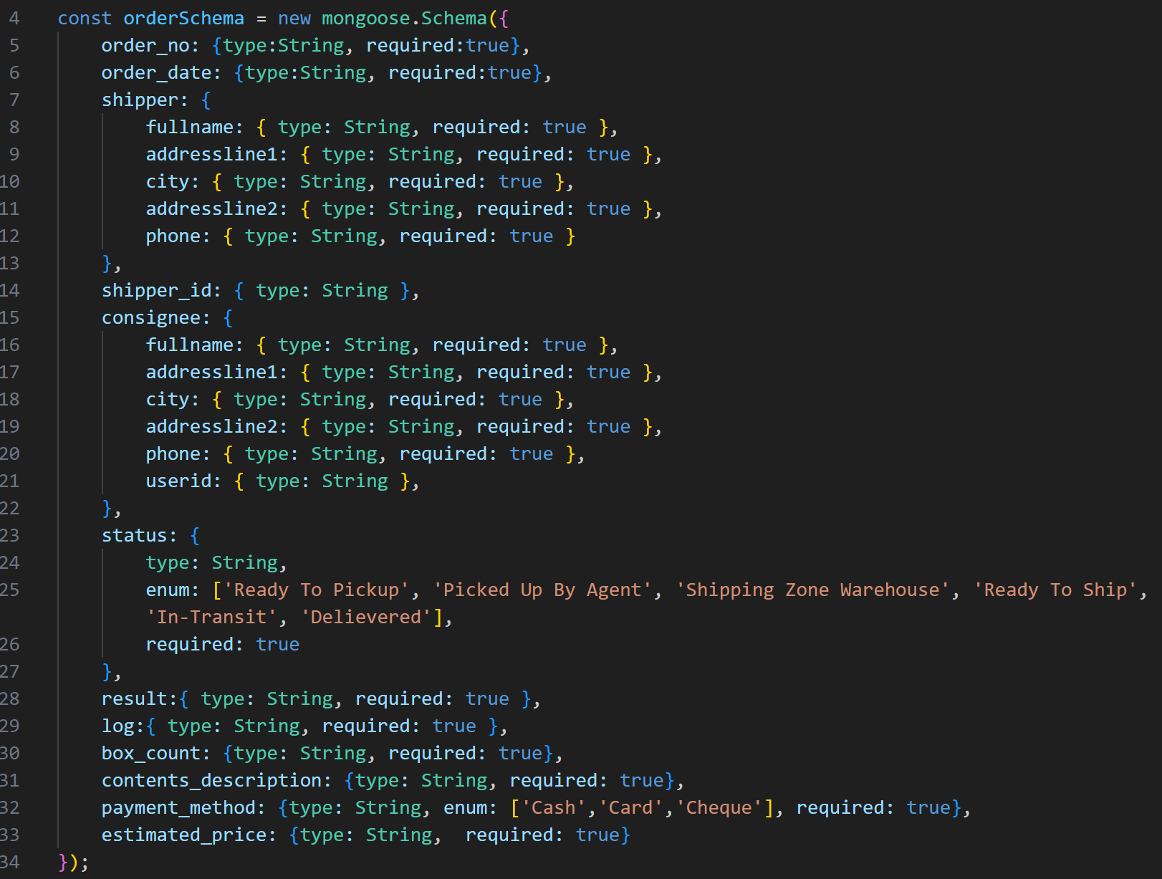

Frontend Order Management (Customer Section):

In the frontend customer section, customers can manage their orders conveniently. They can create new orders, view order history, and track the status of their shipments seamlessly.

Key Features for Frontend Order Management (Customer Section):

* Create New Orders: Easily initiate new orders by providing shipment details, pickup and delivery addresses, and cargo information.
* View Order History: Access a comprehensive list of past orders, including order dates, shipment details, and delivery statuses.
* Track Order Status: Monitor the progress of active orders in real-time, receive status updates, and view delivery confirmations.

**Order Creation Interface:**

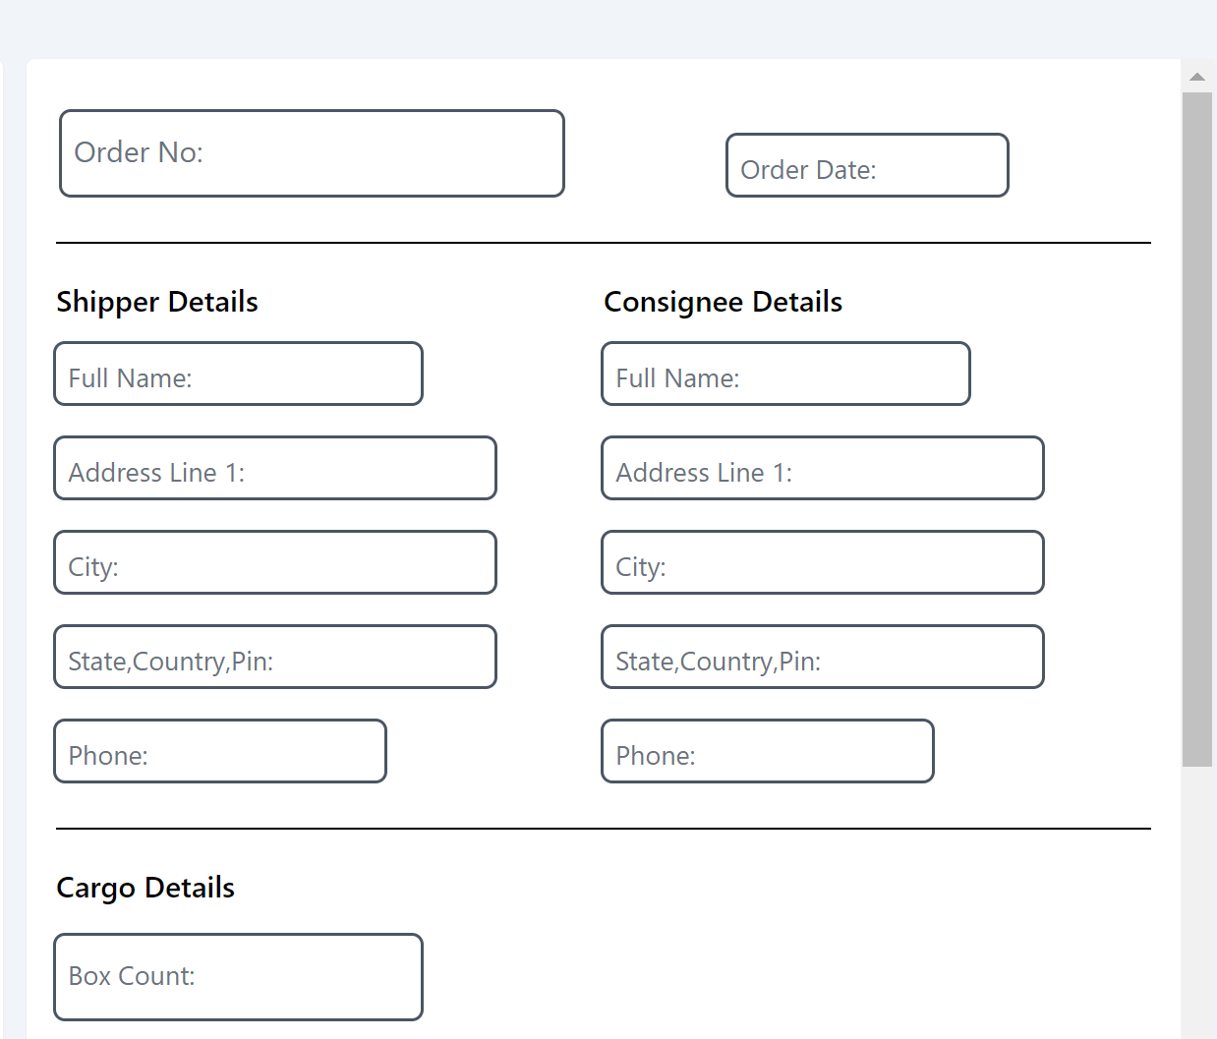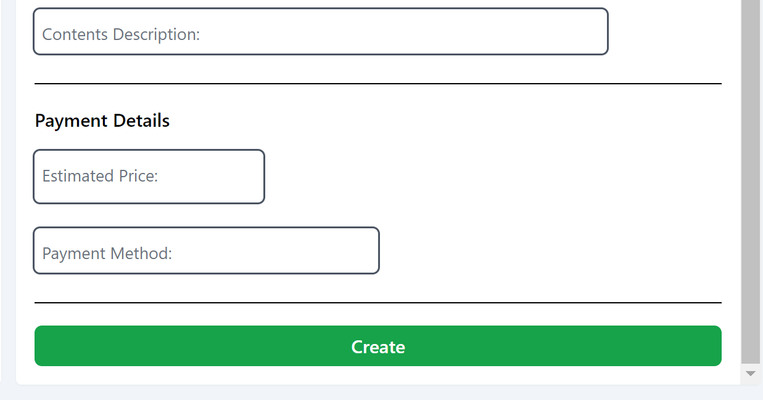

Frontend Order Management (User Section):

In the frontend user section, authorized users such as agents and managers can manage orders on behalf of customers. They have access to advanced order management functionalities and can assign agents, update order statuses, and handle exceptions.

Key Features for Frontend Order Management (User Section):

* Manage Orders: View a list of all orders, search and filter orders based on various criteria, and perform actions such as editing, assigning agents, and updating statuses.
* Assign Agents: Assign agents to specific orders based on availability, location, and workload.
* Handle Exceptions: Resolve order-related issues and exceptions, communicate with customers, and coordinate with other stakeholders to ensure timely resolution.

5. Managing Shipments

Frontend Shipment Creation (Customer Section):

In the frontend customer section, customers can initiate new shipments seamlessly. They can specify pickup details, select delivery options, and receive confirmation of their shipment creation.

Key Features for Frontend Shipment Creation (Customer Section):

* Initiate New Shipments: Access a dedicated shipment creation page to initiate new shipments.
* Specify Pickup Details: Provide pickup location, date, and time for the shipment.
* Select Delivery Options: Choose delivery preferences, including shipping method and delivery address.

**Shipments Dashboard:**

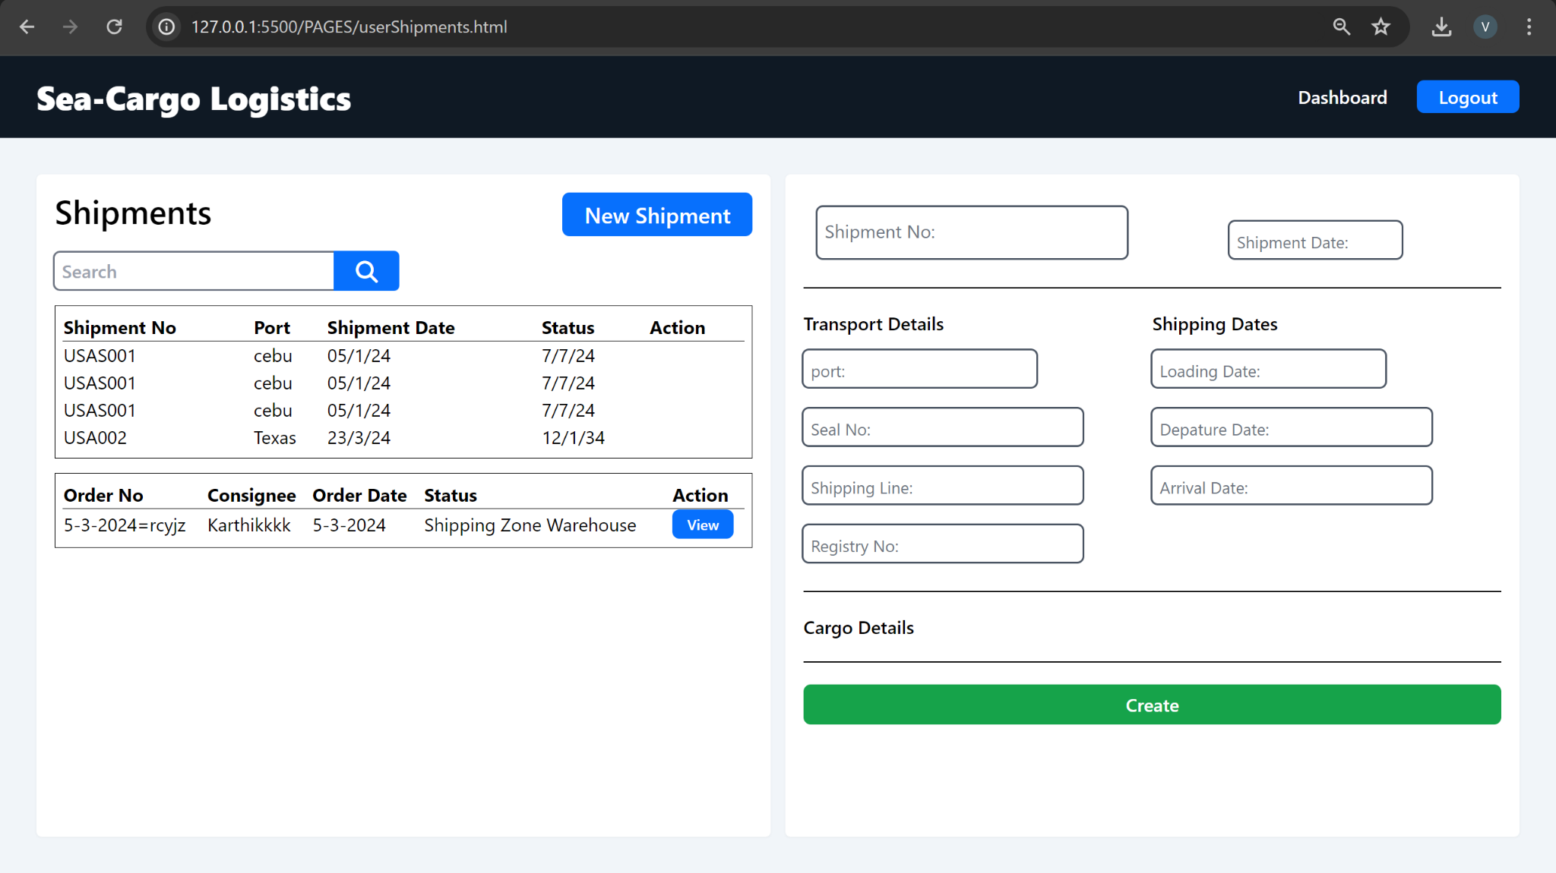

Conclusion

In conclusion, the sea-cargo logistics application provides a comprehensive solution for managing logistics operations efficiently. With intuitive interfaces for both backend administrators and frontend users, the application streamlines processes such as order creation, shipment management, and tracking.

Through this user manual, users can familiarize themselves with the application's features and functionalities, from accessing the system to managing orders and shipments. Whether you're a customer initiating a new shipment or a backend user overseeing logistics operations, the application offers tools and resources to facilitate seamless management of sea-cargo logistics.

As we continue to develop and enhance the application, we welcome feedback and suggestions from users to improve usability, functionality, and overall user experience.